Dental microscope with new integrated 4K camera

Leica Microsystems launches a new generation of the M320 for micro-dentistry

26 October 2021, Wetzlar, Germany. Brilliant, detailed microscope images help dentists to explain treatment options to patients and involve them in decision-making processes to build trust. For this, the new generation of the M320 dental microscope now offers ultra-high resolution imaging with an integrated 4K camera. The additional Leica View App can be used for image streaming of microscope images and video to a mobile device for added viewing flexibility.

“Patients only feel, but cannot see, what is causing their dental problem”, says Chiara Bergerone, Vice President of the Medical Business Unit. “Sharing insights on the medical finding as well as on the later treatment progress is a very important and powerful way for dentists to reinforce patient trust.” The microscope camera provides brilliant images and videos which dentists can display directly on a 4K monitor in the treatment room to illustrate the diagnosis and available treatment options with an example picture or video. “This 4K content can easily be transferred to a computer, so that it can be used for case documentation, impressive presentations, webinars, training events, and publications to grow a dentist’s reputation”, adds Chiara Bergerone.

The 4K camera, Leica View App, and usability make the M320 also a great tool for teaching, as Dr. Katia Greco points out. As an endodontist from Maglie, Italy, who also teaches endodontics as an Adjunct Professor at the Vita-Salute San Raffaele University in Milan, she advocates that dental microscope training should become a standard in education and professional practice. “One can learn to use a microscope in the course of a week”, she says.

Furthermore, the M320 is designed to optimize outcomes of dental treatments and enhance dentists’ working comfort. The visualization capability of the microscope combines high resolution with a great depth of field so that deep, narrow cavities and anatomical structures alike are visible in impressive detail. Two LED light paths distribute light homogenously and deliver a bright, crisp image. To enhance working comfort, the M320 offers a choice of objective lenses, binocular tubes, and ergonomic accessories that suit different body frames, specialties, and working preferences.

“Last, but not least, hygiene and design go together well in the M320,” says Chiara Bergerone. “Routing cables internally makes for sleek, minimalistic design which looks great in the practice, but also makes cleaning the microscope very easy and straightforward.” With its large overhead reach, doctors can also increase the distance between themselves and patients for additional safety. Antimicrobial coating further supports hygiene protocols.

The M320 surgical microscope for dentistry is available from October 2021.

Further information:
Product page: https://www.leica-microsystems.com/products/surgical-microscopes/p/m320-d/
Science Lab article “Covid-19: Mitigating Risks in Dentistry” https://www.leica-microsystems.com/science-lab/covid-19-mitigating-risks-in-dentistry/

Product image
The M320 dental microscope with new integrated 4K camera is designed to optimize outcomes, facilitate patient communication, and enhance working comfort.
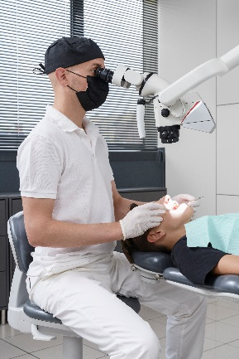
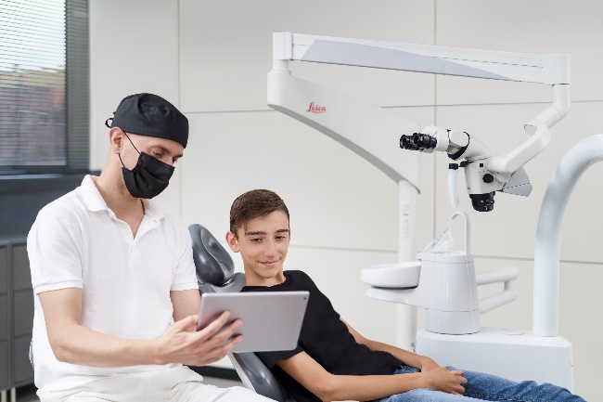

.

Application image
The 4K camera and Leica View App support patient communication.

___________________________________________

About Leica Microsystems
Leica Microsystems develops and manufactures microscopes and scientific instruments for the analysis of microstructures and nanostructures. Ever since the company started as a family business in the nineteenth century, its instruments have been widely recognized for their optical precision and innovative technology. It is one of the market leaders in compound and stereo microscopy, digital microscopy, confocal laser scanning microscopy with related imaging systems, electron microscopy sample preparation, and surgical microscopes.

Leica Microsystems has seven major plants and product development sites around the world. The company is represented in over 100 countries, has sales and service organizations in 20 countries, and an international network of distribution partners. Its headquarters are located in Wetzlar, Germany.

