4K camera in ENT microscope supports patient communication

New generation M320 surgical microscope for ENT from Leica Microsystems

26 October 2021, Wetzlar, Germany. Otolaryngologists must see clearly in deep, narrow cavities to be able to treat conditions of the ear, nose, and throat thoroughly. Brilliant microscope images support them in communicating medical findings to their patients and reinforce trust. The new 4K camera which is integrated into the M320 surgical microscope gives otolaryngologists images of stunning clarity to increase their insights and capture video or images in ultra-high resolution, which they can show to their patients directly in the treatment room.

“If you can share your own view with your patients and suggest treatment options, you show them they are in good hands”, says Chiara Bergerone, Vice President of the Medical Business Unit. “Otolaryngologists can show the 4K images easily on a monitor in the treatment room or transfer them to a PC. Content can be archived in the patient files, and be used to track progress, e.g., when comparing the status before and after a surgery”, continues Chiara Bergerone. In addition, the Leica View App enables otolaryngologists to stream images and videos directly from the integrated camera to, e.g., a tablet, facilitating patient communication further. Sharing knowledge for training or consultation purposes, professional publications, or on a practice’s website and social media channels is equally convenient.

“The M320 is also an ideal teaching microscope”, adds Chiara Bergerone. The 4K camera and App support teaching as students can be guided via large screen projections or share their work among themselves with application pictures on their own devices. “As the M320 is known for its ease of use, students appreciate they can quickly learn how to use the microscope, setting magnification and working distance.”

Furthermore, the M320 is designed to increase otolaryngologists’ insights and enhance comfort during ENT procedures. The visualization capability of the microscope combines high resolution with a great depth of field so that deep, narrow cavities and anatomical structures alike are visible in impressive detail. Two LED light paths distribute light homogenously and deliver a bright, crisp image. To enhance working comfort, the M320 offers a choice of objective lenses, binocular tubes, and ergonomic accessories that suit different body frames, specialties, and working preferences.

“Last, but not least”, says Chiara Bergerone, “internally routed cables and its virtually jointless design make the M320 straightforward to clean, aided by antimicrobial coating to accommodate increasingly demanding hygiene protocols.”

The M320 surgical microscope for ENT is available from October 2021.
Further information:
Product page: https://www.leica-microsystems.com/products/surgical-microscopes/p/m320-o/
Science Lab article “How Clinical and Surgical Microscopes Support Otolaryngology” https://www.leica-microsystems.com/science-lab/how-clinical-and-surgical-microscopes-support-otolaryngology/

Product image
The M320 surgical microscope for ENT with new integrated 4K camera is designed to increase insights, reinforce patient communication, and enhance working comfort.

Application image
The 4K camera and Leica View App support patient communication.
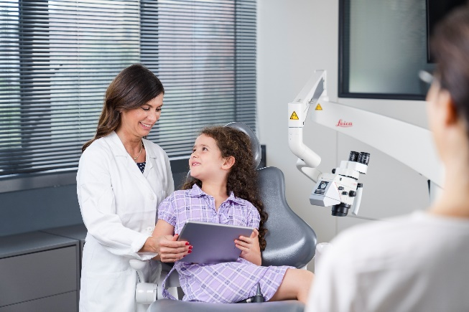
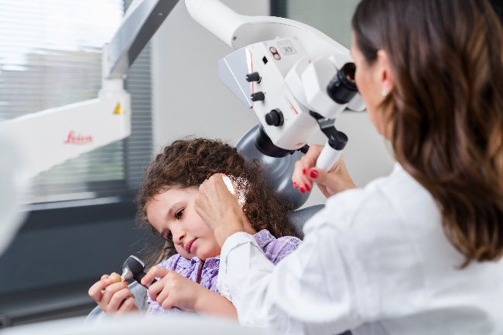

.

___________________________________________

About Leica Microsystems
Leica Microsystems develops and manufactures microscopes and scientific instruments for the analysis of microstructures and nanostructures. Ever since the company started as a family business in the nineteenth century, its instruments have been widely recognized for their optical precision and innovative technology. It is one of the market leaders in compound and stereo microscopy, digital microscopy, confocal laser scanning microscopy with related imaging systems, electron microscopy sample preparation, and surgical microscopes.

Leica Microsystems has seven major plants and product development sites around the world. The company is represented in over 100 countries, has sales and service organizations in 20 countries, and an international network of distribution partners. Its headquarters are located in Wetzlar, Germany.

