AI-powered software allows deeper spatial insights from 3D images

Aivia 14 offers complete multiplexed 3D spatial analysis workflow from cell detection to phenotyping and data exploration

12 June 2024, Wetzlar, Germany – Leica Microsystems, a leading provider of microscopy and scientific instrumentation, has released version 14 of Aivia, its flagship image analysis solution. This update introduces a suite of new features and enhancements for accurate deep-learning based cell segmentation, automated phenotyping and spatial data analysis in 3D multiplexed images. Researchers and scientists can visualize up to 15 channels in 3D multiplexed images simultaneously, providing a comprehensive view of complex biological processes.

“This major new version of Aivia is particularly well suited to contribute to drug development and will catalyze advances in cancer research, immunology and personalized medicine,” says Luciano Lucas, Director Data & Analysis at Leica Microsystems. “Aivia 14 enables users to systematically segment, phenotype and explore heterogeneities in healthy and pathological tissue microenvironments, and this will play a crucial role in determining treatment outcomes.”

"Dealing with massive numbers of data points in complex biological images can be daunting for researchers. Aivia 14 automates this process by leveraging advanced AI algorithms, allowing scientists to seamlessly identify and analyze phenotypes without the need to train deep learning models or code. This not only accelerates their research but also uncovers insights that might have otherwise been missed," adds Won Yung Choi, Product Manager, Data & Analysis at Leica Microsystems.

Aivia’s improved deep learning model accelerates cell detection by up to 78%, resulting in faster and
more accurate detection and partition of cells. This enhancement enables characterization of tissue microenvironments and different phenotypes based on the expression of multiple biomarkers such as disease state or cell type. With the software’s updated dendrogram and dimensionality reduction tools, users can interactively explore phenotypes and gain a deeper understanding of 3D multiplexed image data.

Aivia 14 is available through flexible licensing models that provide users with options to meet their specific lab requirements. Existing Aivia subscribers can access Aivia 14 as part of their subscription for a seamless transition to this cutting-edge update. To learn more about Aivia or to request a free trial, visit https://www.leica-microsystems.com/aivia.

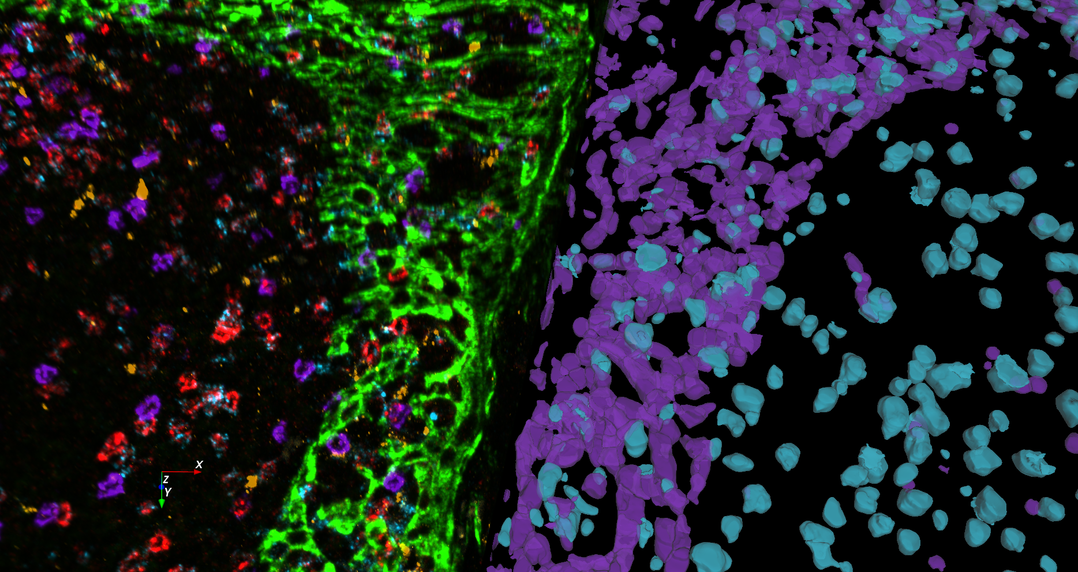
Multiplexed human tonsil tissue labeled with a panel of 8 OPAL dyes and DAPI acquired on a STELLARIS system. Epithelial (purple) and immune (teal) cells are segmented using Aivia 14. ________________________________________

About Leica Microsystems
Leica Microsystems develops and manufactures microscopes and scientific instruments for the analysis of microstructures and nanostructures. Ever since the company started as a family business in the nineteenth century, its instruments have been widely recognized for their optical precision and innovative technology. It is one of the market leaders in compound and stereo microscopy, digital microscopy, confocal laser scanning microscopy with related imaging systems, electron microscopy sample preparation, and surgical microscopes.

Leica Microsystems has six major plants and product development sites around the world. The company is represented in over 100 countries, has sales and service organizations in 20 countries, and an international network of distribution partners. Its headquarters are located in Wetzlar, Germany.

Additional image 2:

