**Leica Microsystems strengthens its partnership with Medana to distribute ophthalmic surgery microscopy solutions in Germany**

**April 2025, Wetzlar, Germany –­** Leica Microsystems, a leading provider of microscopy and scientific information, has strengthened its partnership with Medana to exclusively provide advanced ophthalmology solutions for private sector projects and designated hospitals across Germany. Medana is known for its extensive experience and support in the ophthalmology sector thanks to their expertise in planning, consulting, and optimizing equipment. This partnership ensures that healthcare providers will continue to receive high-quality products, and will lead to improved patient outcomes.

"We are thrilled to strengthen our partnership with Medana. Their dedication to quality and deep knowledge of the market fits perfectly with our mission to provide innovative solutions to improve surgery accuracy and patient care," said Linna Beram, Sales Manager Medical Central Europe, Leica Microsystems.

"Our combined expertise and shared commitment to innovation will ensure that ophthalmic surgeons and their patients in Germany will benefit from the best possible solutions," said Dirk Braas, Managing Director, Medana.

Medana will be at the 37th International Congress of German Ophthalmic Surgery (DOC) taking place in Nuremberg, from 15th - 17th May 2025, with a booth showcasing a dedicated Leica corner. Visitors to the booth will be the first in the country to experience the new Proveo 8x digital ophthalmic surgical microscope from Leica Microsystems.

More information can be found [here](https://www.leica-microsystems.com/company/events/event-details/37-int-kongress-der-deutschen-ophthalmochirurgie-doc/).

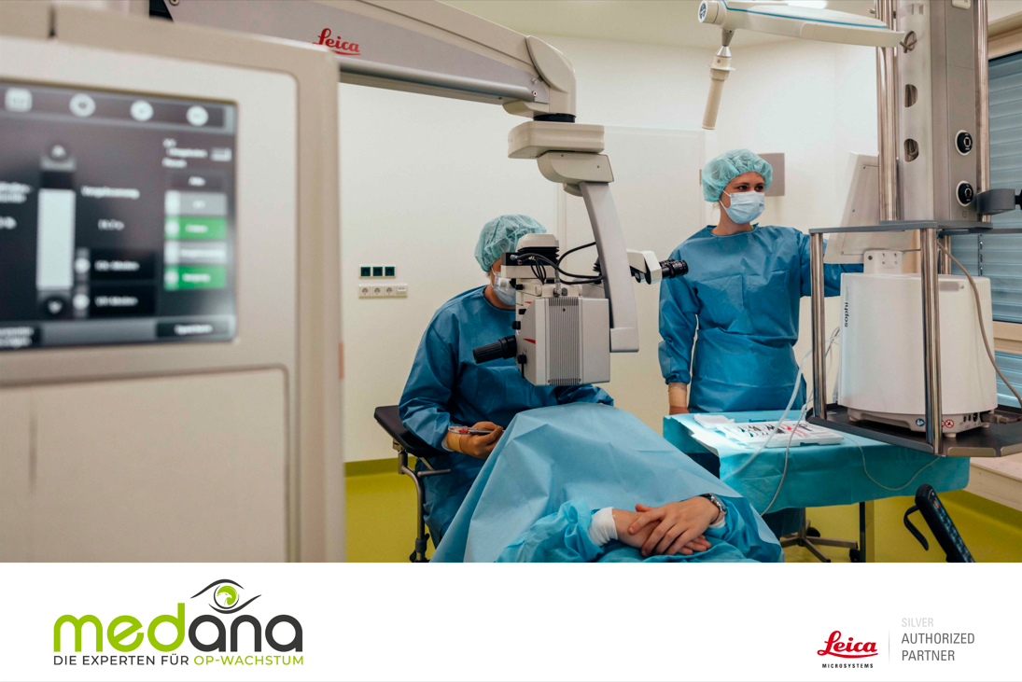

**About Leica Microsystems**

Leica Microsystems develops and manufactures fully integrated solutions for microscopic imaging and scientific instruments to analyze microstructures and nanostructures. Since the company started as a family business in the nineteenth century, its instruments have been widely recognized for their optical precision and innovative technology. It is one of the market leaders in compound and stereo microscopy, digital microscopy, confocal laser scanning microscopy with related imaging systems including AI-enabled image analysis, electron microscopy sample preparation, and surgical microscopes.

Find out more at:

www.leica-microsystems.com