Leica Microsystems Launches ‘Partner Excellence Program’ for Global Channel Partners

11 June 2024, Wetzlar, Germany – Leica Microsystems announces the official launch of its Partner Excellence Program (PEP) for leading channel partners who outperformed regional growth requirements and will have access to additional benefits.
The Partner Excellence Program is strategically designed to give Leica Microsystems’ channel partners a competitive edge in today's fast-paced market landscape.

"At Leica Microsystems, we recognize the pivotal role our channel partners play in driving our business forward," said Darin Stell, Senior VP Global Commercial Operations at Leica Microsystems. "With the Partner Excellence Program, we are committed to empowering our partners with the necessary resources and expertise to achieve success."

Key highlights of the Partner Excellence Program include:

- Enhanced Market Recognition: Partners can enjoy increased visibility and credibility in the marketplace through the esteemed association with the Leica Microsystems brand, a leading microscope and scientific equipment manufacturer.
- Access to Resources: Gain exclusive access to a robust array of sales, marketing, and technical support resources to fuel business growth.
- Incremental Discounts: Enjoy escalating product and demo discounts as partners progress through program tiers.
- Personalized Business Consultancy: Receive tailored guidance and knowledge support to validate expertise and drive strategic initiatives.
- Field Support: Access comprehensive service-related support, including specialized training and technical guidance.

Furthermore, each tier of the Partner Excellence Program offers a unique set of benefits, including personalized business assessment plans, co-marketing funds, demo rentals, and participation in exclusive partner events and customer success case studies.

The Partner Excellence Program encompasses tier-badge classifications with each tier offering recognition and rewards based on the partner's commitment and accomplishments.

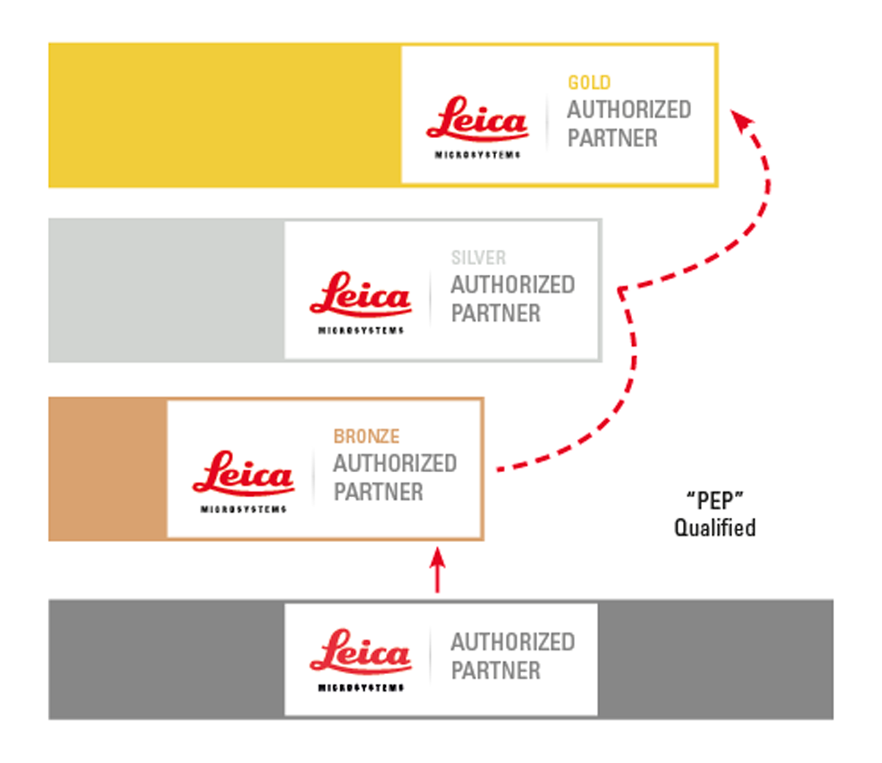

To qualify for participation in the Partner Excellence Program, partners must fulfill specific criteria, including completing compliance trainings, generating incremental business opportunities, and achieving higher market share through local sales and marketing channels.

"Our commitment to our partners is unwavering," added Darin. "Through the Partner Excellence Program, we aim to foster a collaborative ecosystem where partners can thrive, driving mutual success and delivering exceptional value to customers."

The criteria and rewards of the Partner Excellence Program are subject to regional thresholds and rewards may vary depending on local requirements.
Partners are encouraged to consult their regional Sales Director and or Channel Partner Manager for their respective ’PEP’ criteria.
___________________________________________

Notes to Editors

About Leica Microsystems
Leica Microsystems develops and manufactures microscopes and scientific instruments for the analysis of microstructures and nanostructures. Ever since the company started as a family business in the nineteenth century, its instruments have been widely recognized for their optical precision and innovative technology. It is one of the market leaders in compound and stereo microscopy, digital microscopy, confocal laser scanning microscopy with related imaging systems, electron microscopy sample preparation, and surgical microscopes. Leica Microsystems is a subsidiary of Danaher, a leading global life sciences and diagnostics innovator, committed to accelerating the power of science and technology to improve human health.

