Leica Microsystems shapes the future of ophthalmic surgery with real-time 3D visualization and unmatched comfort

The Proveo 8x 3D digital microscope for ophthalmology debuts at ASCRS 2025 Los Angeles.

25th April 2025, Wetzlar, Germany – Leica Microsystems, a leading provider of microscopy and scientific instrumentation, has launched Proveo 8x, a 3D digital ophthalmic microscope with real-time 3D imaging, at the Annual Meeting of The American Society of Cataract and Refractive Surgery (ASCRS) in California, USA.

Attendees discovered how surgeons can work comfortably with flexible monitor and viewing options for 3D surgery and view enhanced information from the Optical Coherence Tomography (OCT) and phacoemulsification (phaco) system in real time, fully integrated into a surgical cockpit view. The unique C-arm design of Proveo 8x provides an unobstructed view across various setups in 3D heads-up surgery. In combination with a 55-inch, or a 32-inch flexarm-monitor, surgeons can work comfortably in their preferred visualization setup.

With advanced 3D imaging technology and color enhancement capabilities, Proveo 8x provides enhanced insights of ocular tissues and structures. It delivers an immersive view with accurate colors and texture representation, as well as depth resolution – regardless of the viewing options. Consequently, surgeons can make more targeted and well-informed decisions in real-time.

“Proveo 8x combines optical microscope excellence with an exclusive high-sensitivity native 3D 4K medical camera, uniquely developed by Leica Microsystems. With the exceptional 3D real-time imaging of the Proveo 8x, we take surgeons 3D experience to another level with no perceivable latency, depth of field control, higher resolution and instant light adaptation,” said Aysar Ziyadeh, Vice President, Medical Business Unit, Leica Microsystems. “It's time for surgeons to access the digital future with Proveo 8x, where they can interchange between various visualization possibilities such as binocular-based or 3D heads-up surgery. By using the MyVeo headset, surgeons can reimagine how they see, move, and collaborate.”

MyVeo, the all-in-one surgical visualization headset, provides a live 3D view directly in front of the surgeon’s eyes. It frees surgeons from the binoculars or external monitors, delivering a single integrated view with seamless data integration from phaco and OCT. Additionally, teaching and learning with MyVeo is impactful, as up to three headsets can be used simultaneously, sharing the same live 3D view as the main surgeon.

Thanks to the open architecture of Proveo 8x, surgeons have the choice of adopting 3D technology today or in the future. Surgeons can further rely on a high workflow efficiency with the Proveo 8x 3D digital microscope with programmed settings and an intuitive user interface, and they can enjoy working with the best of Leica optics.

For more information, please visit https://go.leica-ms.com/proveo8x.

Image caption: Proveo 8x 3D Digital Microscope from Leica Microsystems

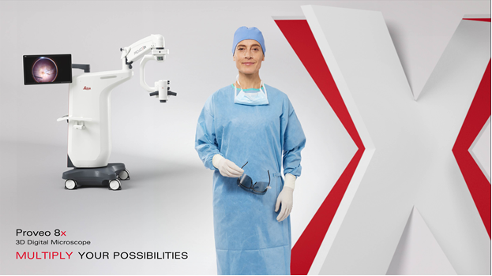

___________________________________________

About Leica Microsystems
Leica Microsystems develops and manufactures fully integrated solutions for microscopic imaging and scientific instruments to analyze microstructures and nanostructures. Since the company started as a family business in the nineteenth century, its instruments have been widely recognized for their optical precision and innovative technology. It is one of the market leaders in compound and stereo microscopy, digital microscopy, confocal laser scanning microscopy with related imaging systems including AI-enabled image analysis, electron microscopy sample preparation, and surgical microscopes.

Find out more at:
www.leica-microsystems.com

